Task:

Roll no: 213064

Name: Khansa

**Android App Integration with Google Map Manual :**

1. CREATED A NEW PROJECT NAMED AS MAP:

* Main activity.file
* Manifiest.xml file

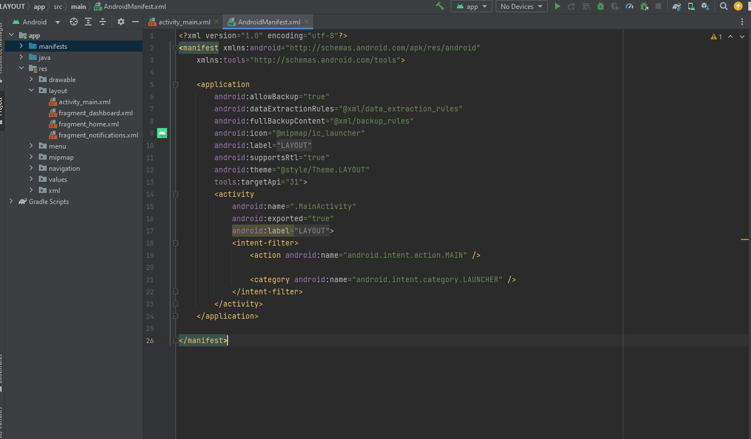

1. Api key is created in a credantials :

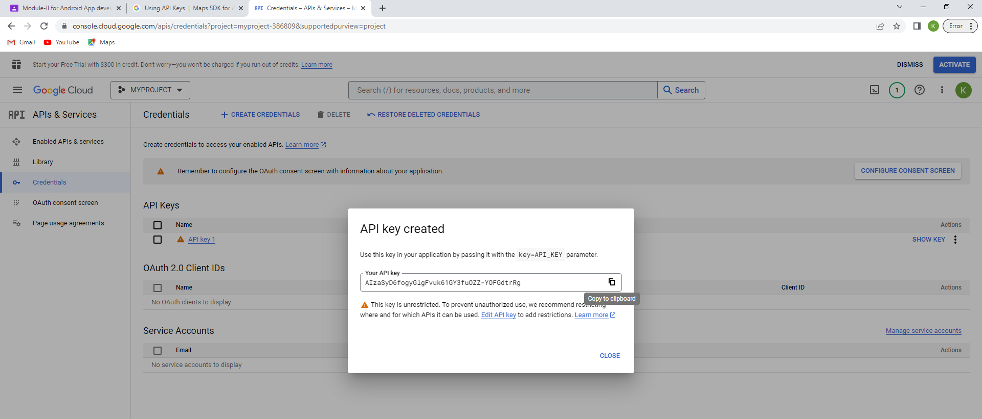

1. Location in a map:

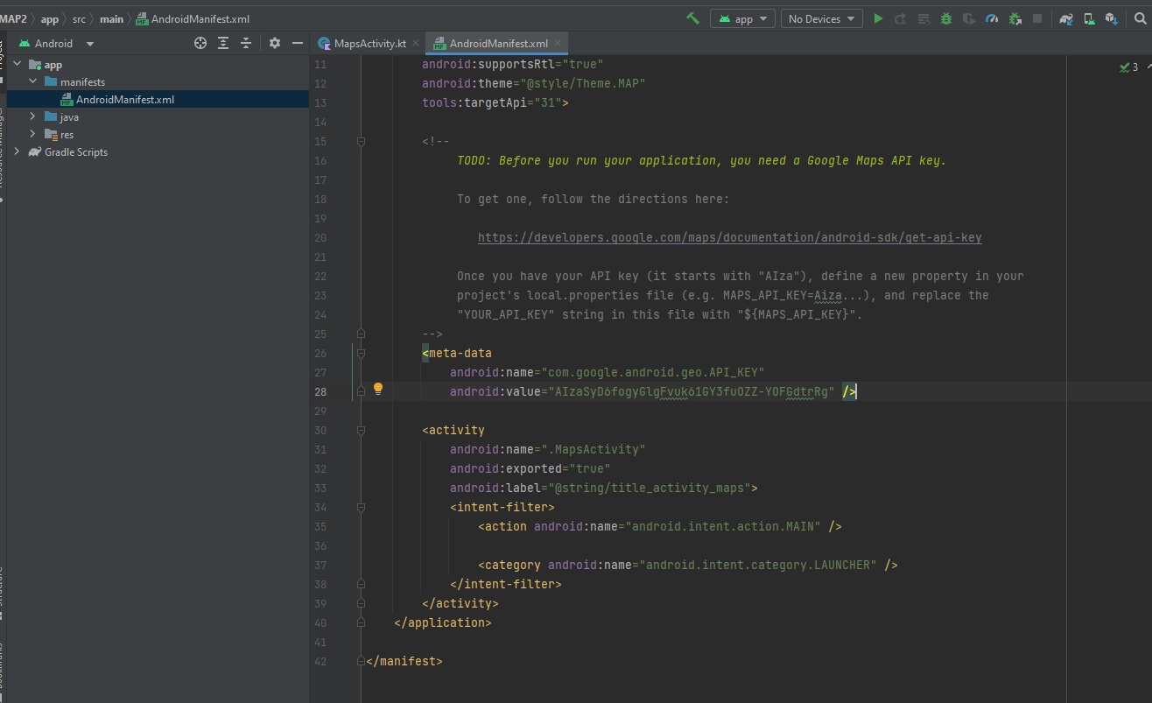

1. Add map markers:

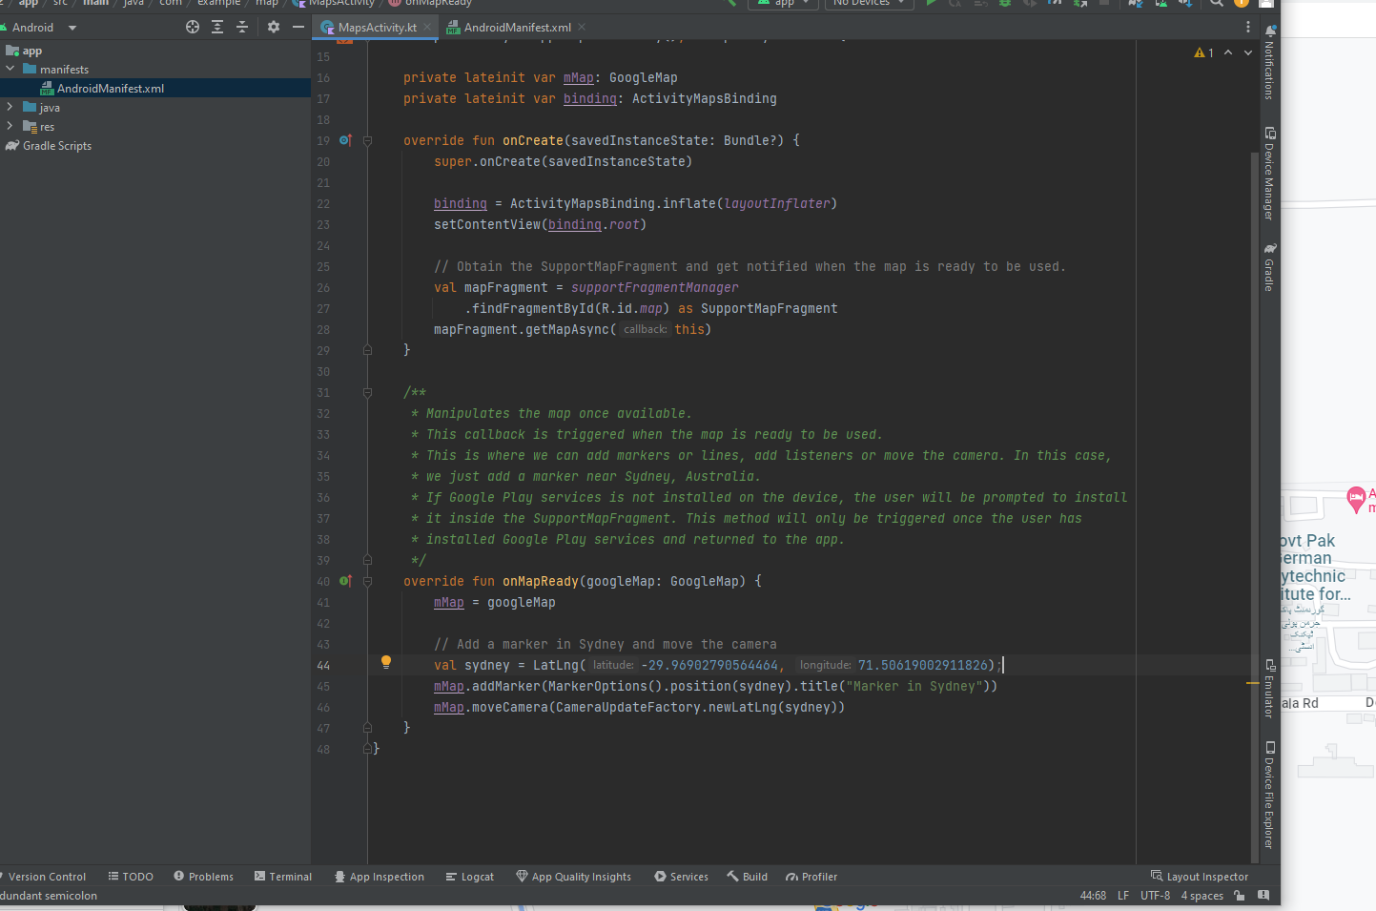

1. Add map location as AUMC :

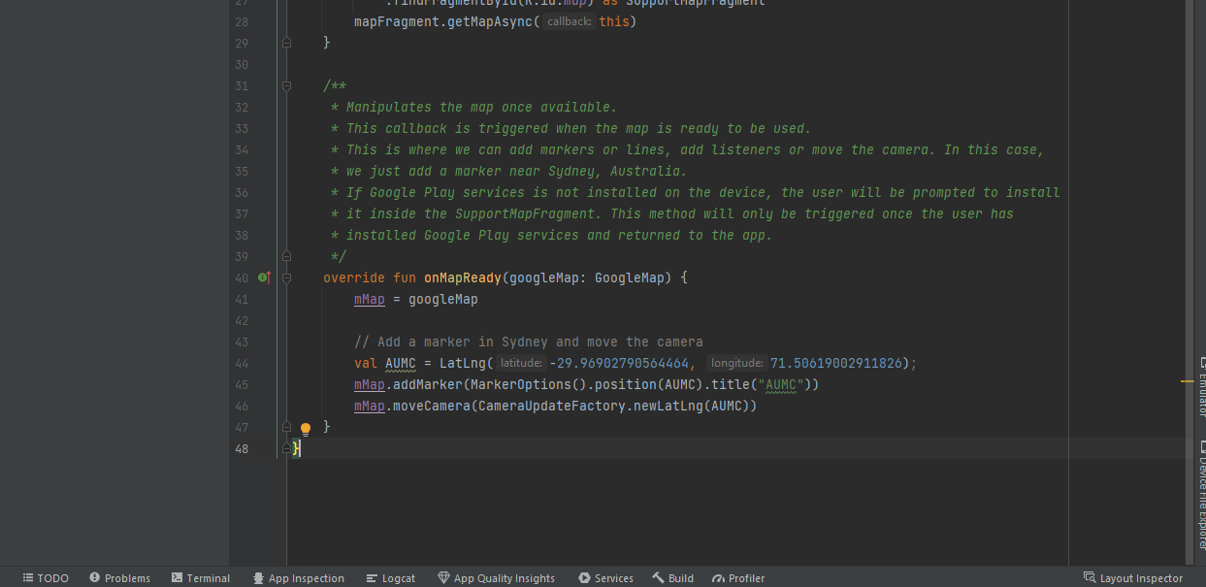

1. Add map types

The type of map that your user wants depends on the kind of information they need. When using maps for navigation in your car, it's helpful to see street names clearly. When you are hiking, you probably care more about how much you have to climb to get to the top of the mountain. In this step, you add an app bar with an options menu that allows the user to change the map type.

To create a new menu XML file, right-click on your res directory and select New > Android Resource File.

In the dialog, name the file map_options. Choose Menu for the resource type. Click OK.

